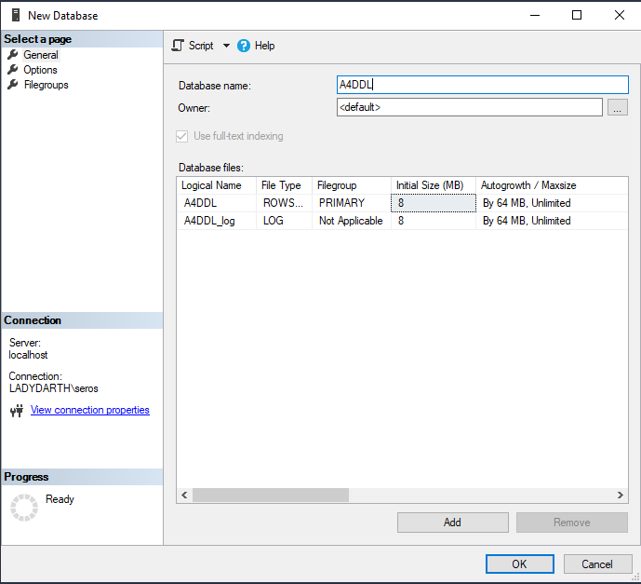

**2.1 – studentId is an ‘identity column’ and cannot be empty**

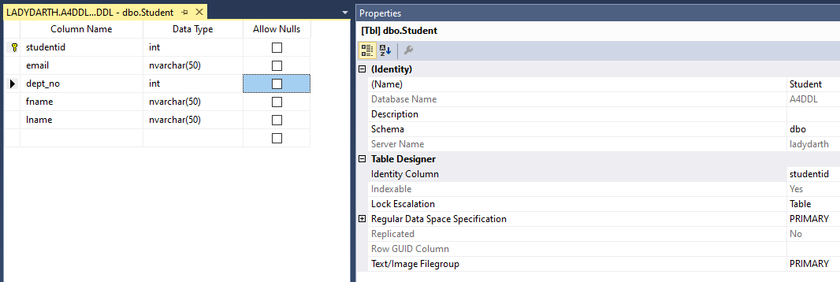

**2.5 – assignmentid is an ‘identity column’ and cannot be empty**

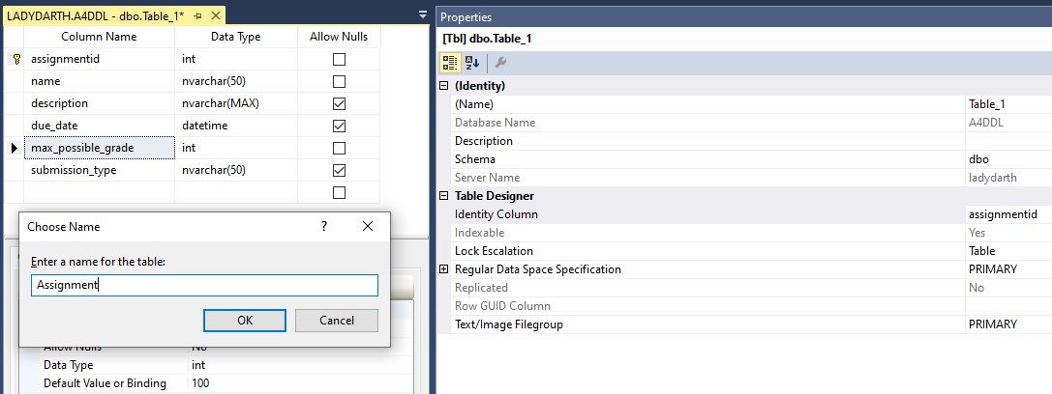

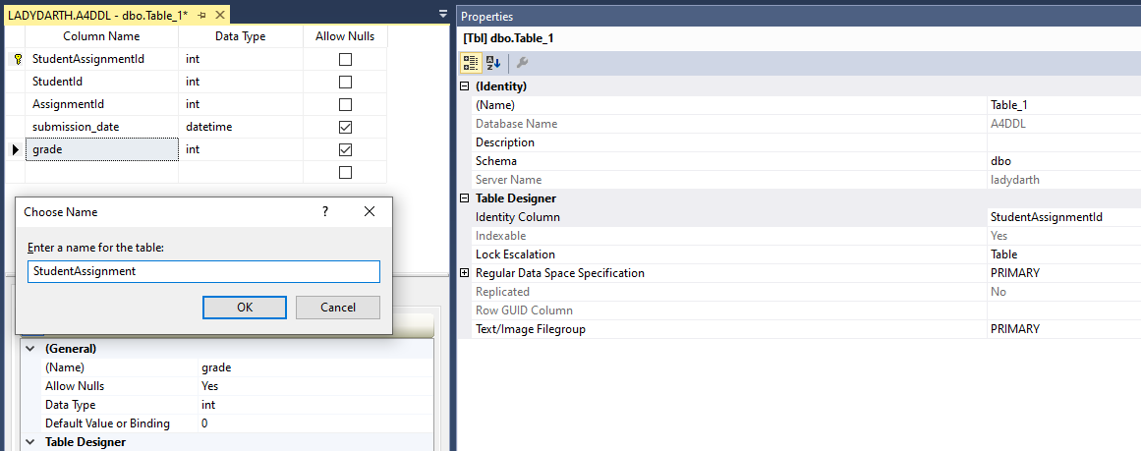

**2.2 – email must be unique**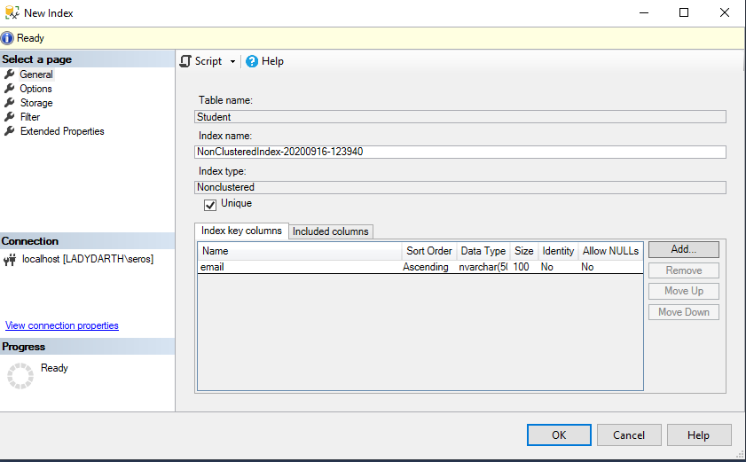



**At the time of doing this assignment, the StudentAssignmentPDF would fail to download and I didn’t realize until looking at question 2.3 that dept_no was not actually a number but an acronym/code, so I ended up switching the column property type from int to char(4). That’s why above you’ll see it as an int.**

**2.3 – dept_no must be one of the following values and length <= 4**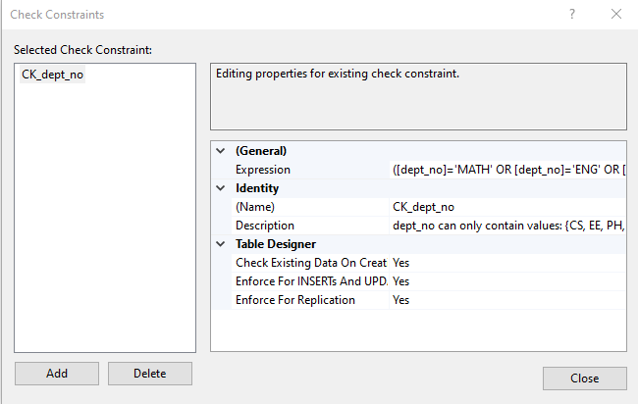

([dept_no]='MATH' OR [dept_no]='ENG' OR [dept_no]='PH' OR [dept_no]='EE' OR [dept_no]='CS')

* Length is automatically handled because the largest value accepted contains 4 characters

**2.4 – fname and lname cannot be empty**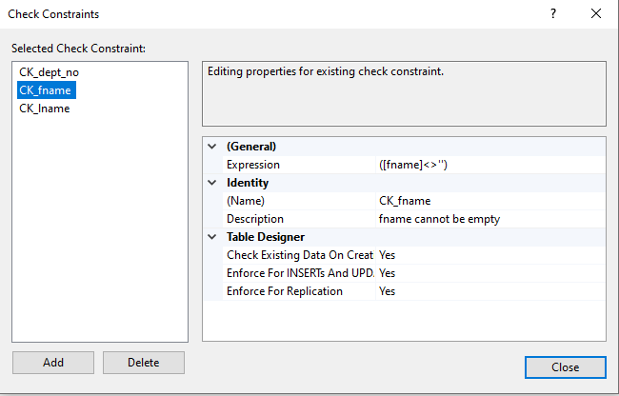

****** I did the same thing as above for the CK_lname

**2.6 – assignment.name has a dummy value**

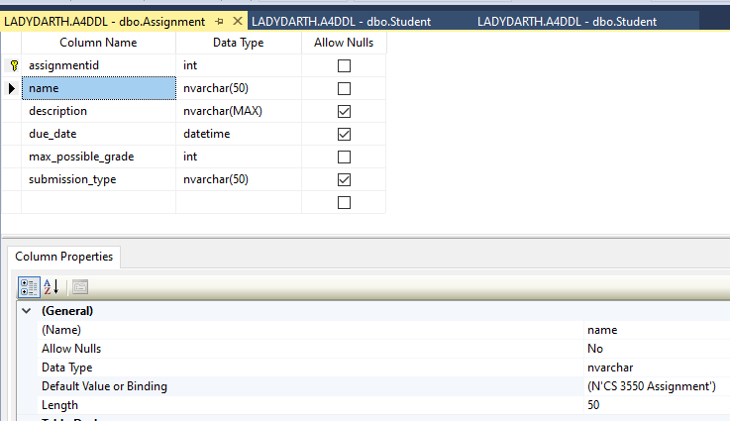

**2.7 – assignment.description is nullable**

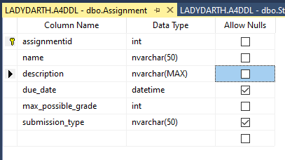

**2.8 – assignment.due_date is not nullable**

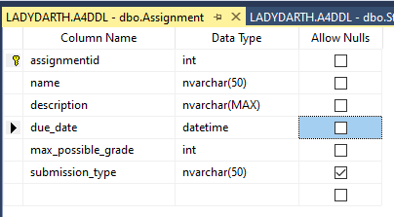

**2.9 – 0 <= assignment.max_possible_grade <= 200**

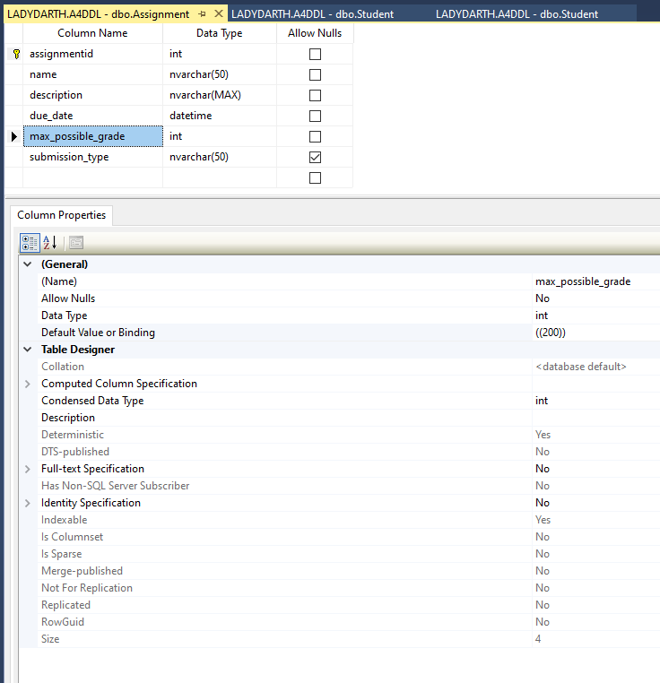

**I set default here to 200 and then the constraints are below.**

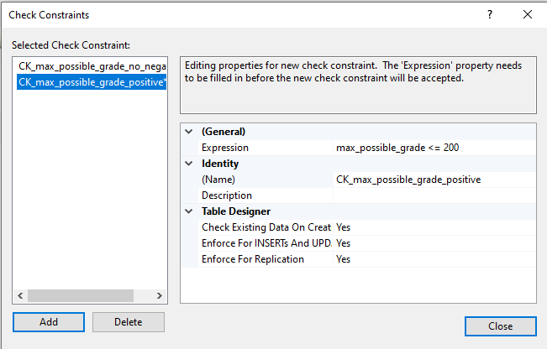

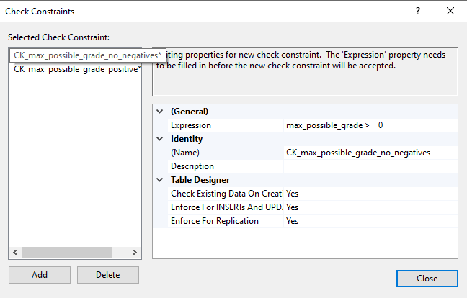

**2.10 – studentassignment.grade is between 0 to 200**

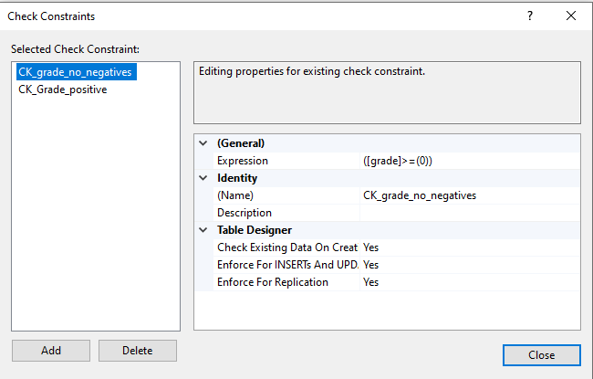 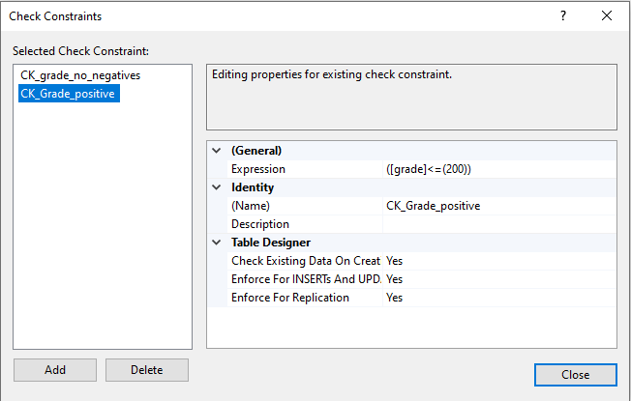

**2.11 –assignment.submission_type**

